**CS_HW02_solutions**

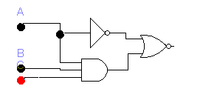**PB16030899 Zhu Heqin**

|  |  |  |  |
| --- | --- | --- | --- |
| A | B | C | X |
| 0 | 0 | 0 | 0 |
| 0 | 0 | 1 | 0 |
| 0 | 1 | 0 | 0 |
| 0 | 1 | 1 | 0 |
| 1 | 0 | 0 | 1 |
| 1 | 0 | 1 | 1 |
| 1 | 1 | 0 | 1 |
| 1 | 1 | 1 | 0 |

|  |  |  |  |
| --- | --- | --- | --- |
| A | B | C | Y |
| 0 | 0 | 0 | 1 |
| 0 | 0 | 1 | 1 |
| 0 | 1 | 0 | 1 |
| 0 | 1 | 1 | 1 |
| 1 | 0 | 0 | 1 |
| 1 | 0 | 1 | 1 |
| 1 | 1 | 0 | 1 |
| 1 | 1 | 1 | 0 |

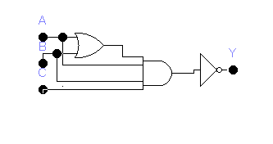

2

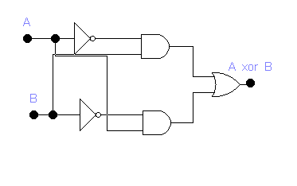

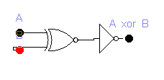

1. One practicable solution  
   From up to down,from left to right : C B A B A C B

|  |  |  |  |
| --- | --- | --- | --- |
| A | B | C | Y |
| 0 | 0 | 0 | 1 |
| 0 | 0 | 1 | 1 |
| 0 | 1 | 0 | 1 |
| 0 | 1 | 1 | 1 |
| 1 | 0 | 0 | 1 |
| 1 | 0 | 1 | 0 |
| 1 | 1 | 0 | 1 |
| 1 | 1 | 1 | 0 |

1. 3.36 is a 2-line-mux :  
    which function is select the input signal according to the input of signal A  
   3.37 is a latch :  
    which function is to store a signal. We can see, if the input of B is 1,change A from 0 to 1 won’t change the output signal D. But , if the input of signal B is 0, then when A is 0, D is 1, and D changes from 1 to 0 when A is set to 1.
2. 3 3 12 96

6

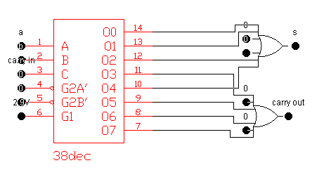

|  |  |  |  |  |
| --- | --- | --- | --- | --- |
| A | B | C | D | Y |
| 0 | 0 | 0 | 0 | 0 |
| 0 | 0 | 0 | 1 | 0 |
| 0 | 0 | 1 | 0 | 1 |
| 0 | 0 | 1 | 1 | 1 |
| 0 | 1 | 0 | 0 | 0 |
| 0 | 1 | 0 | 1 | 1 |
| 0 | 1 | 1 | 0 | 0 |
| 0 | 1 | 1 | 1 | 1 |
| 1 | 0 | 0 | 0 | 0 |
| 1 | 0 | 0 | 1 | 1 |
| 1 | 0 | 1 | 0 | 1 |
| 1 | 0 | 1 | 1 | 1 |
| 1 | 1 | 0 | 0 | 0 |
| 1 | 1 | 0 | 1 | 1 |
| 1 | 1 | 1 | 0 | 1 |
| 1 | 1 | 1 | 1 | 1 |

7.

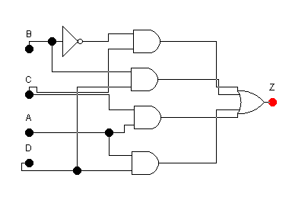

1. a.

|  |  |  |
| --- | --- | --- |
| A | B | Y |
| 0 | 0 | E |
| 0 | 1 | L |
| 1 | 0 | G |
| 1 | 1 | E |

b. G = A and (not B), L = B and (not A), ,E = (A and B) or (not A and not B)

1. 110000 12
2. a. 34  
   b. 7  
   c. Every element’s circuit won’t influence each other ,thus there won’t be delay .

11.

|  |  |  |  |  |  |
| --- | --- | --- | --- | --- | --- |
| desired floor | | Current floor | | Result floor | |
| I1 | I0 | C1 | C0 | 01 | O0 |
| 0 | 0 | 0 | 0 | 0 | 0 |
| 0 | 0 | 0 | 1 | 0 | 1 |
| 0 | 0 | 1 | 0 | 0 | 0 |
| 0 | 0 | 1 | 1 | 0 | 0 |
| 0 | 1 | 0 | 0 | 0 | 0 |
| 0 | 1 | 0 | 1 | 0 | 1 |
| 0 | 1 | 1 | 0 | 1 | 0 |
| 0 | 1 | 1 | 1 | 0 | 1 |
| 1 | 0 | 0 | 0 | 1 | 0 |
| 1 | 0 | 0 | 1 | 0 | 1 |
| 1 | 0 | 1 | 0 | 1 | 0 |
| 1 | 0 | 1 | 1 | 1 | 1 |
| 1 | 1 | 0 | 0 | 1 | 1 |
| 1 | 1 | 0 | 1 | 1 | 1 |
| 1 | 1 | 1 | 0 | 1 | 0 |
| 1 | 1 | 1 | 1 | 1 | 1 |

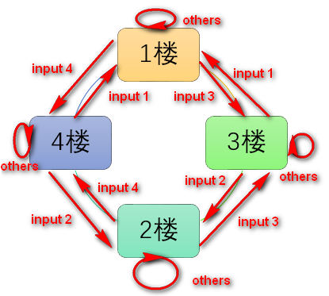

Notice that when push the buttun ,its’s marked with 1,2,3,4 floor. For electric digital infomations , 00 represent the first floor , 01 repe the second, and so on.